D479 Kevin Phitsanu

A. Create a timeline of the UX design activities that will take place during this project.

**Week 1: Research, Analysis and Wireframe Development**

Week 1 of the design process will include research and analysis for Taniti. For this, we will utilize the survey information about current tourists, and the document about the island to analyze what the island has for tourist needs. This will aid in a personal profile research task.

**Week 2: Wireframe Development and Design**

For week 2, we will conduct wireframe development and design. The wireframes will outline the website design.

**Week 3: Prototype Development**

For week 3, we will conduct the development of the website prototype. We will focus on turning the wireframe into an interactive prototype. It will allow for real user website use simulation. It will also aid in prototype testing and creating usability tasks for the users.  
  
**Week 4: Testing and Deployment**

While keeping usability tasks in mind, we will conduct guerilla testing and deployment planning in the last week. If during testing something is not satisfactory, changes and modifications will be made during this phase. Once all testing is completed, then we can continue to the next phase which is deployment planning.

B. User persona  
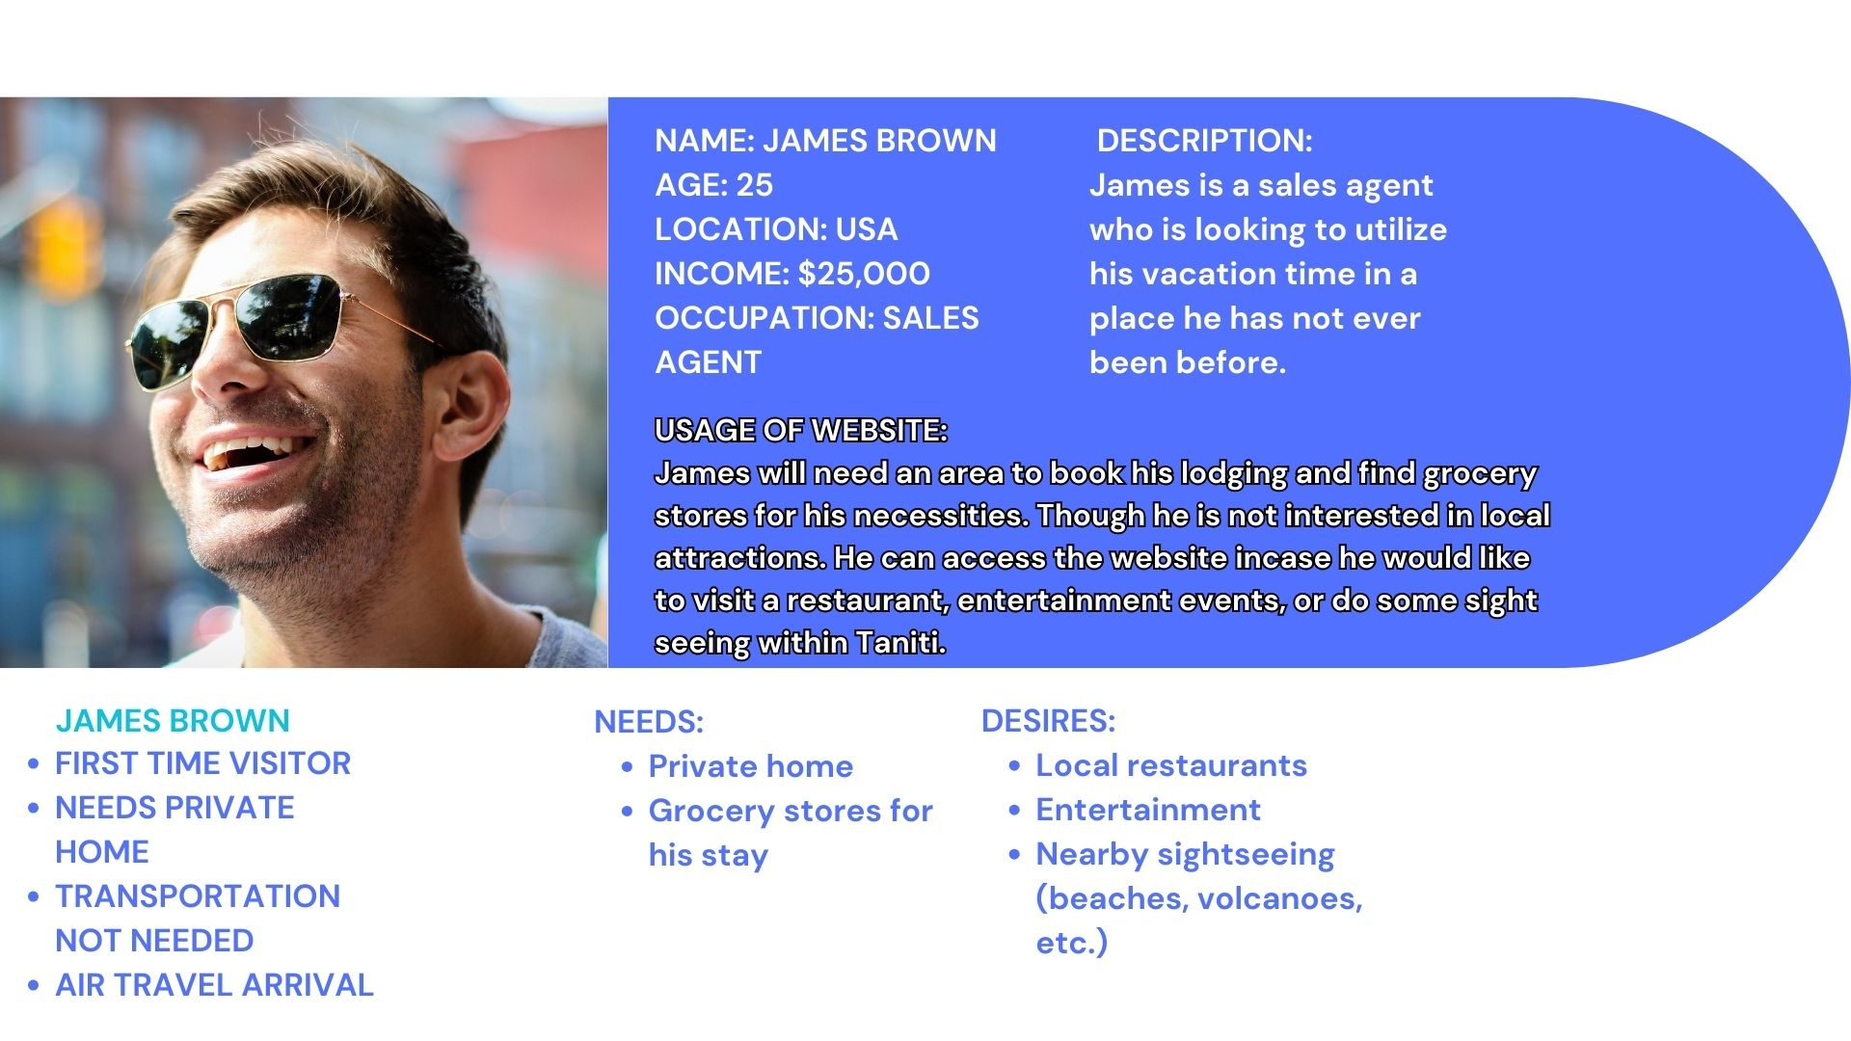

C. Low-fidelity wireframe

Home Page  
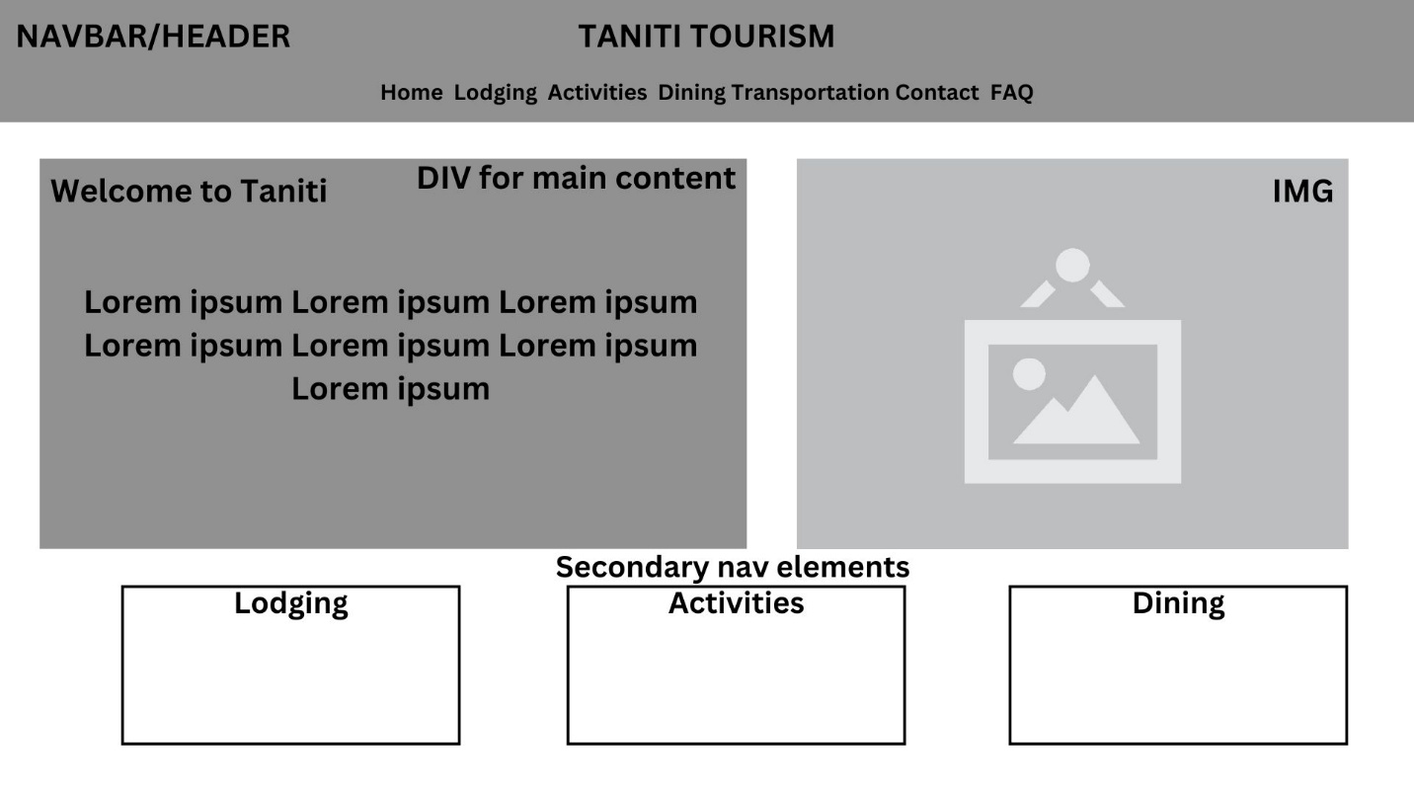

Lodging Page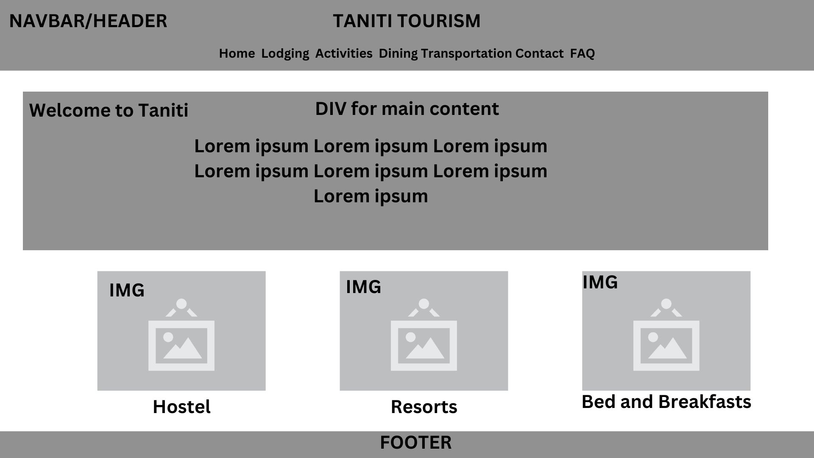  
  
Activities Page